**Mid Term Solution**

**1. What is Data Independence? Explain the different types of Data Independence. 2 Marks**

**Solution:**

* Data independence can be defined as the capacity to change the schema at one level of database system without changing the schema at the higher level. Only the mapping between the two levels is changed. There are two types of data independence:
* Logical: It is the capacity to change the conceptual schema without changing external schema or application program. We may change the conceptual schema to expand or reduce the database
* Physical: It is the capacity to change the internal schema without changing conceptual schema or external schema. We may change the internal schema to reorganize the physical files.

**2. Explain the distinctions among the terms primary key, candidate key, and super key. 2 Marks**

**Solution:**

* A super key is a set of one or more attributes that, taken collectively, allows us to identify uniquely an entity in the entity set. A super key may contain extraneous attributes. If K is a super key, then so is any superset of K.
* A super key for which no proper subset is also a super key is called a candidate key. It is possible that several distinct sets of attributes could serve as candidate keys.
* The primary key is one of the candidate keys that is chosen by the database designer as the principal means of identifying entities within an entity set.

**3. Consider these relations (tables), where the underlined attributers are the keys:**

**Supplier(scode, sname, status, scity) Part(pcode, pname, color, weight, pcity)**

**Supplier_Part(scode, pcode, qty)**

**Write SQL queries for each of these:**

**a) Display the supplier names who supply at least one red part.**

**b) Display the supplier names who do not supply part 425**

**Solution:**

* select distinct sname from supplier where supplier.scode in (select scode from supplier_part where supplier_part.pcode in(select pcode from part where part.color='red'));
* select distinct sname from supplier where not exists(select * from supplier_part where supplier_part.scode=supplier.scode and supplier_part.pcode=425);

**4. Discuss the steps involved in the query processing.** **2 Marks**

**Solution:**

* It involve translation of high level query(SQL) into low level expressions (Relational algebra) that can be used at the physical level of file system, query optimization and actual execution of the query to get the result.

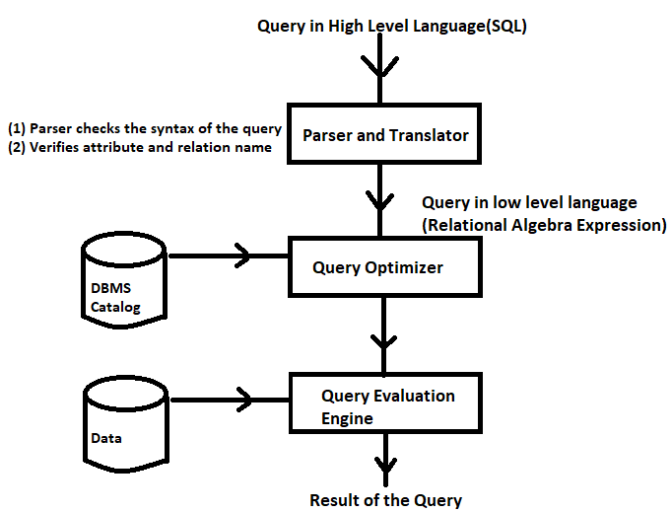

**5. Suppose you are given the following requirements for a simple database for the Indian Premier League (IPL): 6 Marks**

**• IPL has many teams**

**• Each team has a name, a city, a coach, a captain, and a set of players**

**• Each player belongs to only one team**

**• Each player has a name, a position (batsman, bowler, all-rounder, wicket keeper), a skill level, and a set of injury records**

**• Team captain is also a player**

**• a game is played between two teams (referred to as host_team and guest_team) and has a date (such as May 11th, 1999) and a score (such 201/7, 199/6).**

**Construct a clean and concise ER diagram for the IPL database. List your assumptions and clearly indicate the cardinality mappings as well as any role indicators in your ER diagram.**

**Solution:**

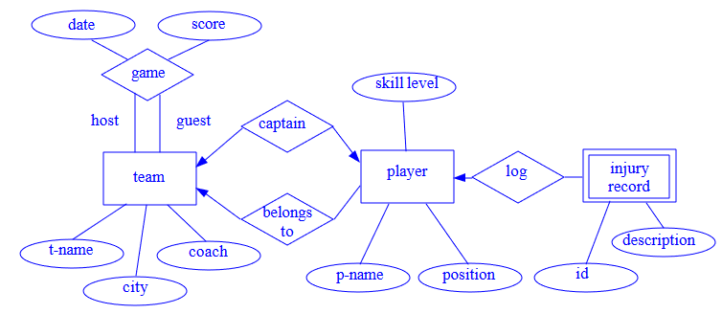

**6. Consider a relation R(A, B, C, D, E) with FD's:{ A → B, BC → E, ED → A}**

* **List all the keys of R**
* **Identify the functional dependencies that violate 2NF, 3NF, BCNF. Solution:**

Candidate keys are CDE, ACD, BCD

R is in 2NF, 3NF but not in BCNF